

**Solution:-**

First we need to register piggybank.jar



We have created reference named A below and we have loaded the file **Crimes_-2001_to_present.csv**. and we have loaded it using **CSVExcelStorage()** function. Now relation is referring the file named **Crimes_-2001_to_present.csv**.



Totally there are 22 columns in **Crimes_-2001_to_present.csv**. We can call them as $0 to $21 depending on the column position. Here we took 2 columns and named $14 as fbi_code, $1 as case_id. Now we have **typecasted.** For each and every row of A, these 2 columns will be generated(retrieved) and it will be referred by **B**.



We have filtered relation B by **fbi_code as “32”.**



We have **grouped Relation C by all** and is **referred by Relation D**.



There are **no cases for fbi_code 32**. So I have **filtered fbi_code as 26.**

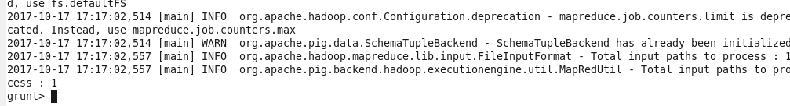

We have filtered relation B by **fbi_code as “26”** and is referred by relation E**.**



We have **grouped Relation E by all** and is **referred by Relation temp_outp**.



We have loaded the file that is referred by Relation temp_outp using **dump command.**



We have described the file that is referred by Relation temp_outp.



Now for each group in D, we are counting the number of innerbag E. So that we can get the no of cases investigated under fbi_code as 26.



We have loaded the file that is referred by Relation outp using **dump command.**



**OUTPUT FOR FBI_CODE 26:-**

